Environmental and Experiment’s conditions

Some of the most important measurements of the experiment were the pressure (P), temperature (T), and humidity (H) determination inside and outside the experiment. These variables are measured inside the Sensorbox (using the index “in”), and outside the Sensorbox while inside the Ecobox (using the index “out”). The environmental conditions (using the index “env”) were not measured by the experiment’s components, but they are provided by the BEXUS gondola.

In the following paragraphs these measurements, alongside others relevant to temperature, will be presented.

# Ascending

The variables Tout and Pout as functions of the gondola’s altitude are given in the below graph, regarding the ascending phase.

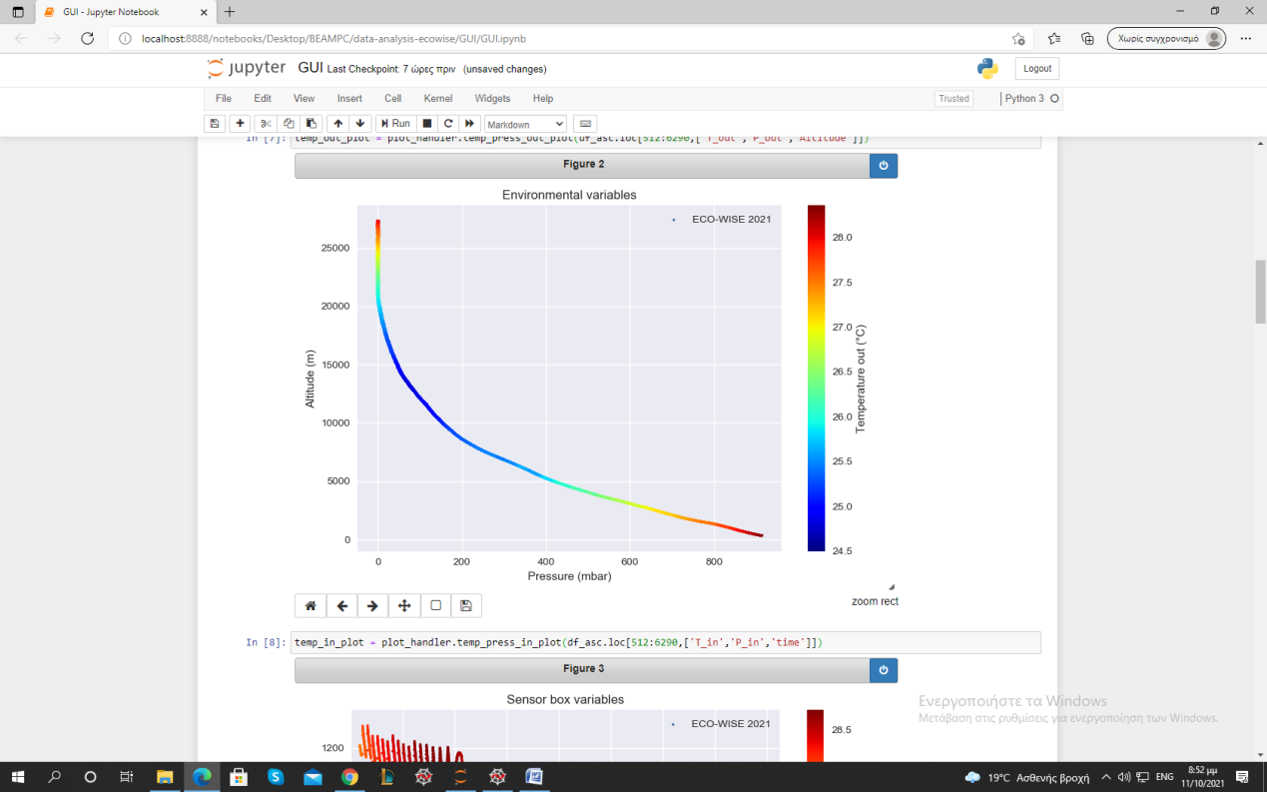

Graph 1: Environmental variables (P, T)

The extrema values of Tout were [24.5 oC, 28.5 oC]. In comparison with the ambient temperature, these are extremely high, even without being inside the Sensorbox. Παραπομπή στο Thermal για την αιτία αυτού. (Γιώργος <3)

Όταν πάρω τις πραγματικές P out, Tout , να συγκρίνω με αυτές, ΕΙΔΙΚΑ ΠΙΕΣΗ

The ascending phase ended at 27.3 km, and it was linear. The mean gondola’s velocity was about 3.7 m/sec.

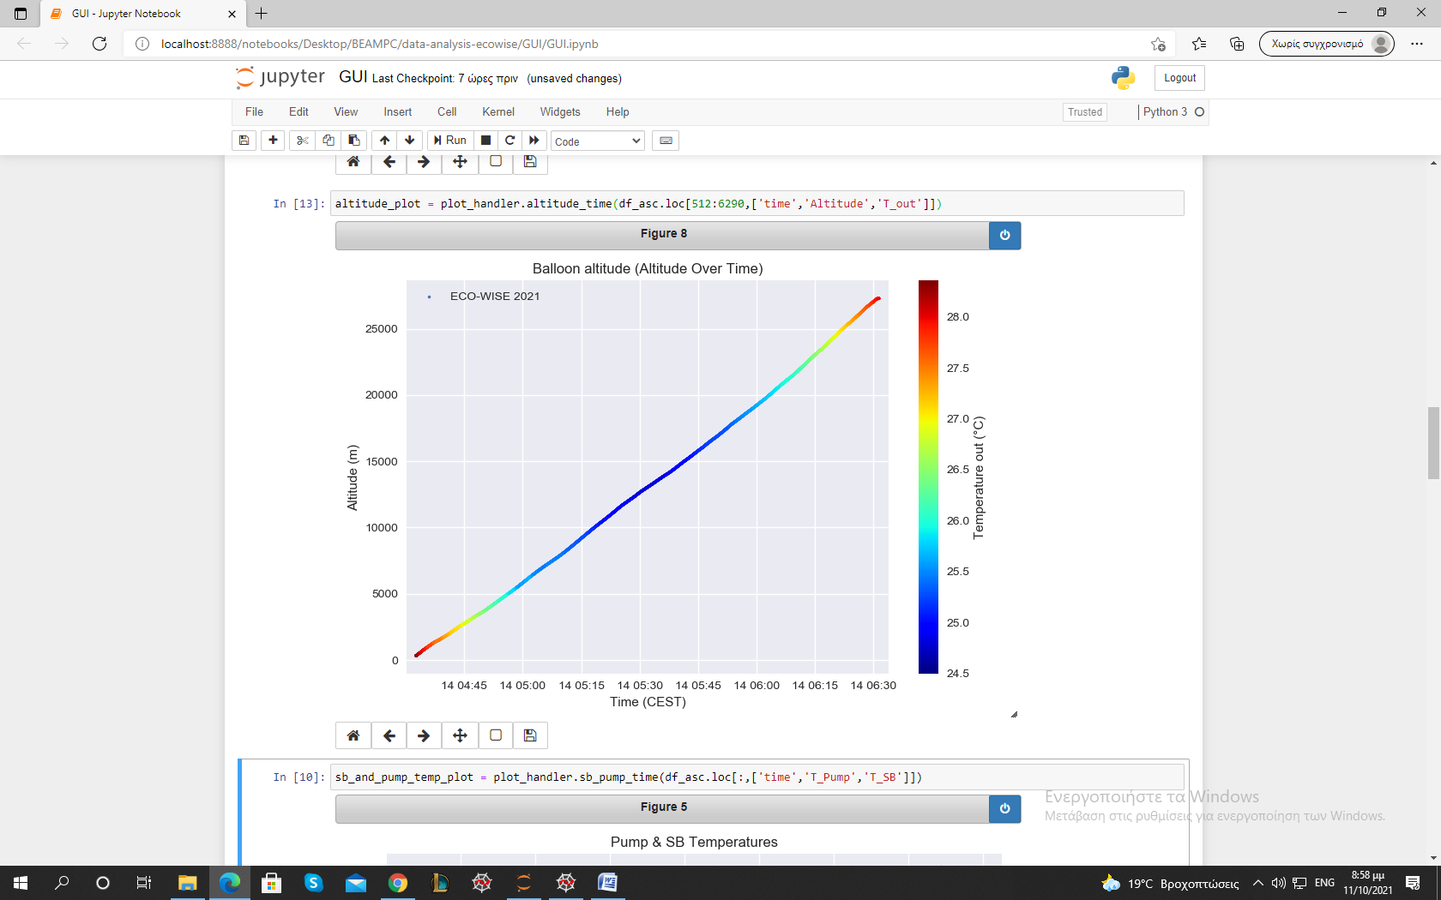

Graph 2: Balloon altitude over time

The sensor’s and the pump’s temperatures were also very high in comparison with the ambient. We observe similar behavior during this phase. These components also contributed to the thermal preservation of the whole experiment. (Γιώργος <3)

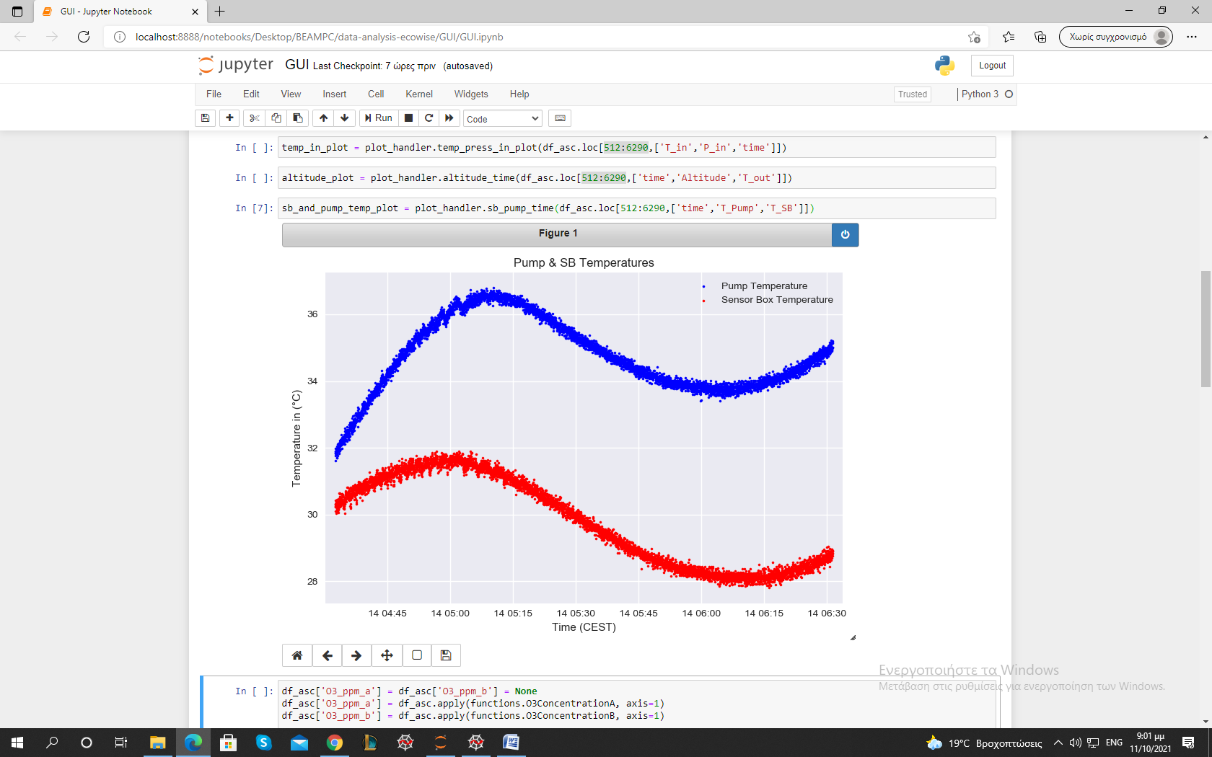

Graph 3: Pump and sensor temperature.

Humidity inside and outside the sensorbox throughout the ascending phase was within the specified performance requirements. The extrema values of the outside Humidity were measured to be 1,03% and 19,79% (Σύγκριση με BEXUS). Humidity inside the box was measured to be greater than outside at every stage but also steadily declining while the balloon was ascending, with its extrema values being ranging from 4.35 % to 26.2 %. The periodic fluctuation in humidity due to the pump’s function can clearly be seen in the graph.

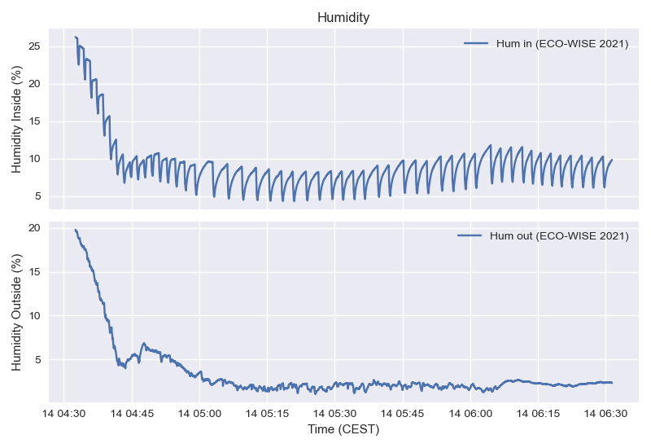

Graph 4: Humidity measures inside and outside of the sensorbox

The temperature and pressure inside the sensorbox as a function of time during the ascending phase are presented below.

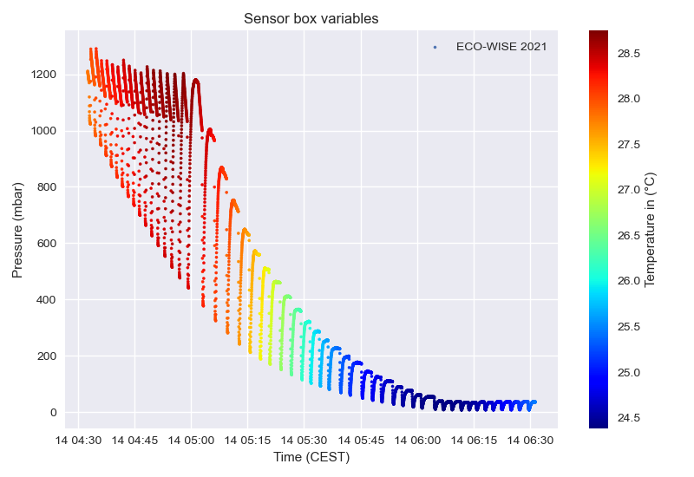

Graph 5: Sensorbox Variables (Ascending phase)

The inside temperature remained well within the specified range of [-40 oC ,60 oC ] throughout the ascending phase. In fact, it remained surprisingly stable between 24 oC and 29 oC which indicates that HEATERS???? Λειτουργια αντλιας;; insulation? (Γιώργος).

Conversely, the pressure inside the sensorbox did not meet the performance requirements during the ascending phase (steady pressure of 800mbar). As is evident in the graph above, the pump was not able to continuously raise the pressure sufficiently at any cycle. Unfortunately, it was determined that there was a leak somewhere in the sensorbox which resulted in the pressure inside essentially matching the atmospheric pressure. It should be noted that the selected pump could have perhaps not been perfectly suited for the required pressurization but it is hypothesized that it would yield acceptable results were it not for the leak. The measured extrema values were [6.5 mbar , 1290.9 mbar].

# Floating

During the floating phase the pressure was extremely low and therefore the pressure sensor was not reliable. There are even negative values.

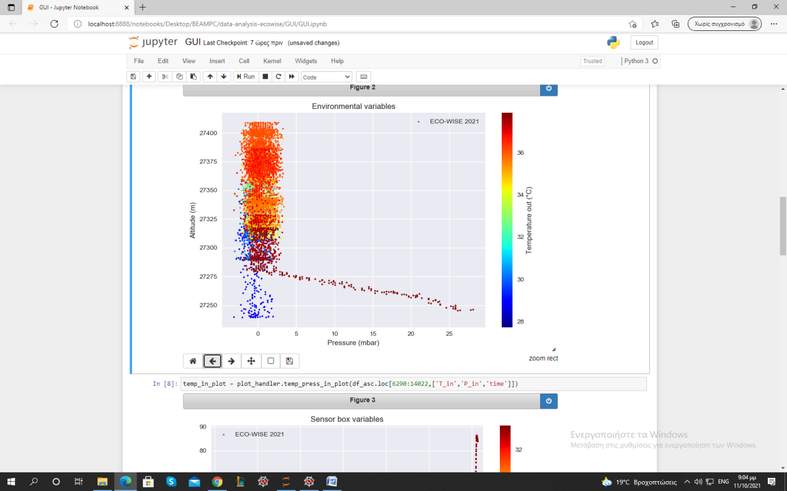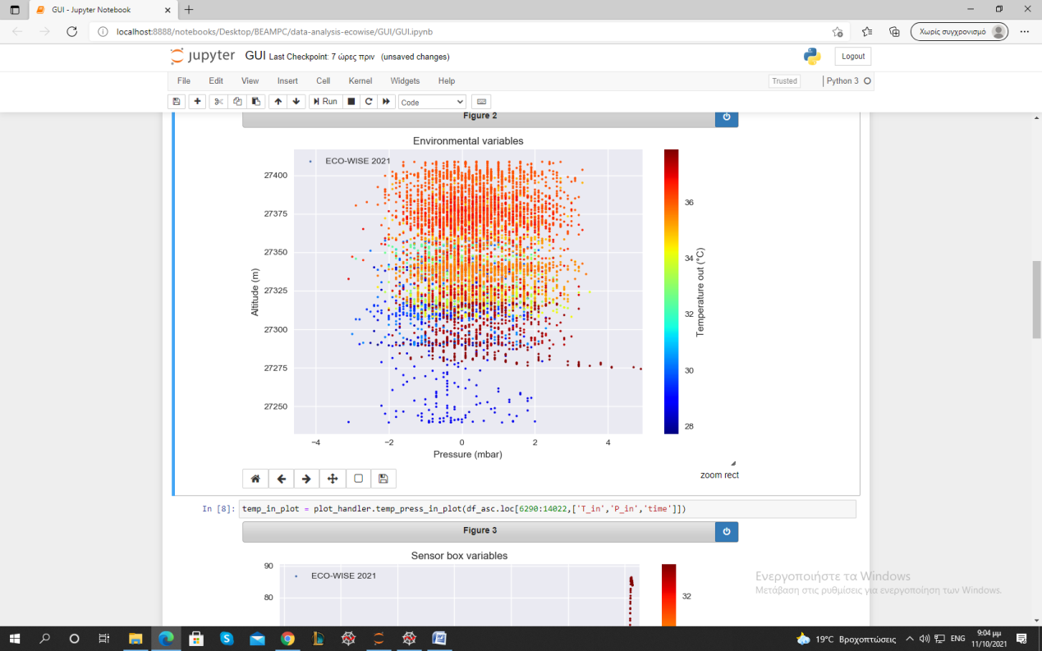

ΠΩΣ ΤΟ ΕΞΗΓΩ;;; ΜΗΠΩΣ ΤΑ ERRORS ΕΙΝΑΙ ΠΟΛΥ ΜΕΓΑΛΥΤΕΡΑ ΑΠΟ ΤΟ ΕΥΡΟΣ; ΜΗΠΩΣ ΔΕΝ ΜΕΤΡΑΕΙ ΑΠΟ ΜΙΑ ΠΙΕΣΗ ΚΑΙ ΚΑΤΩ;

The fluctuations in the altitude during the floating phase are presented in the following graph. In this phase the connection was lost for some minutes and this is the reason of the first wide gap in the data. The other discontinuities are attributed to the restarting of the experiment in order to change the maximum value of Pin, since the pump was not capable of reaching the initial pressure target.

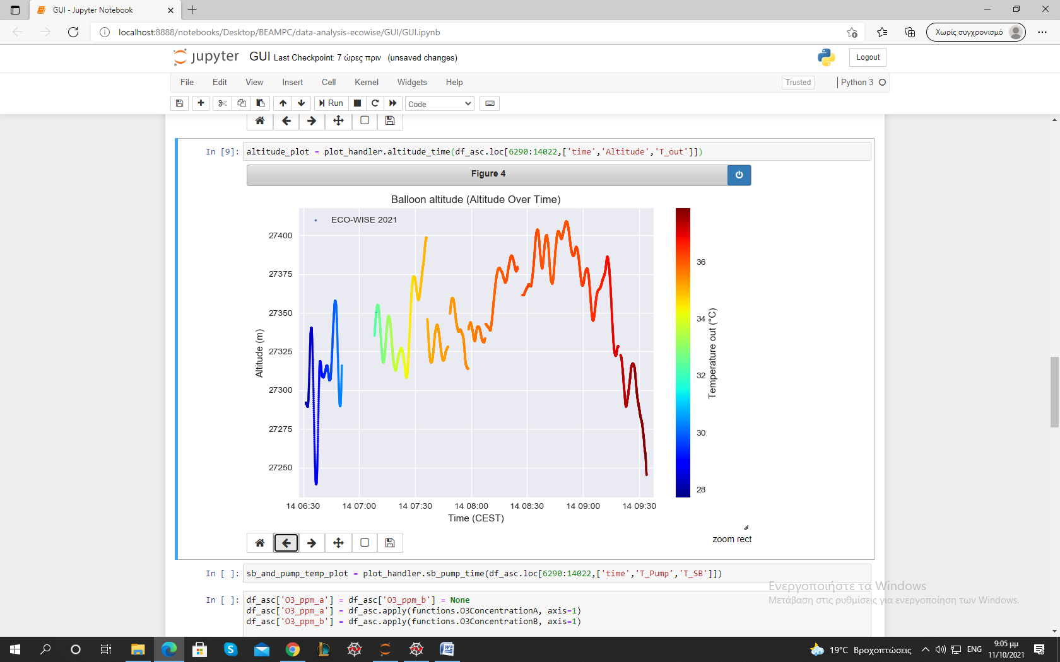

The component’s temperature in the floating phase increased. ΓΙΑΤΙ??? (Γιώργος <3)

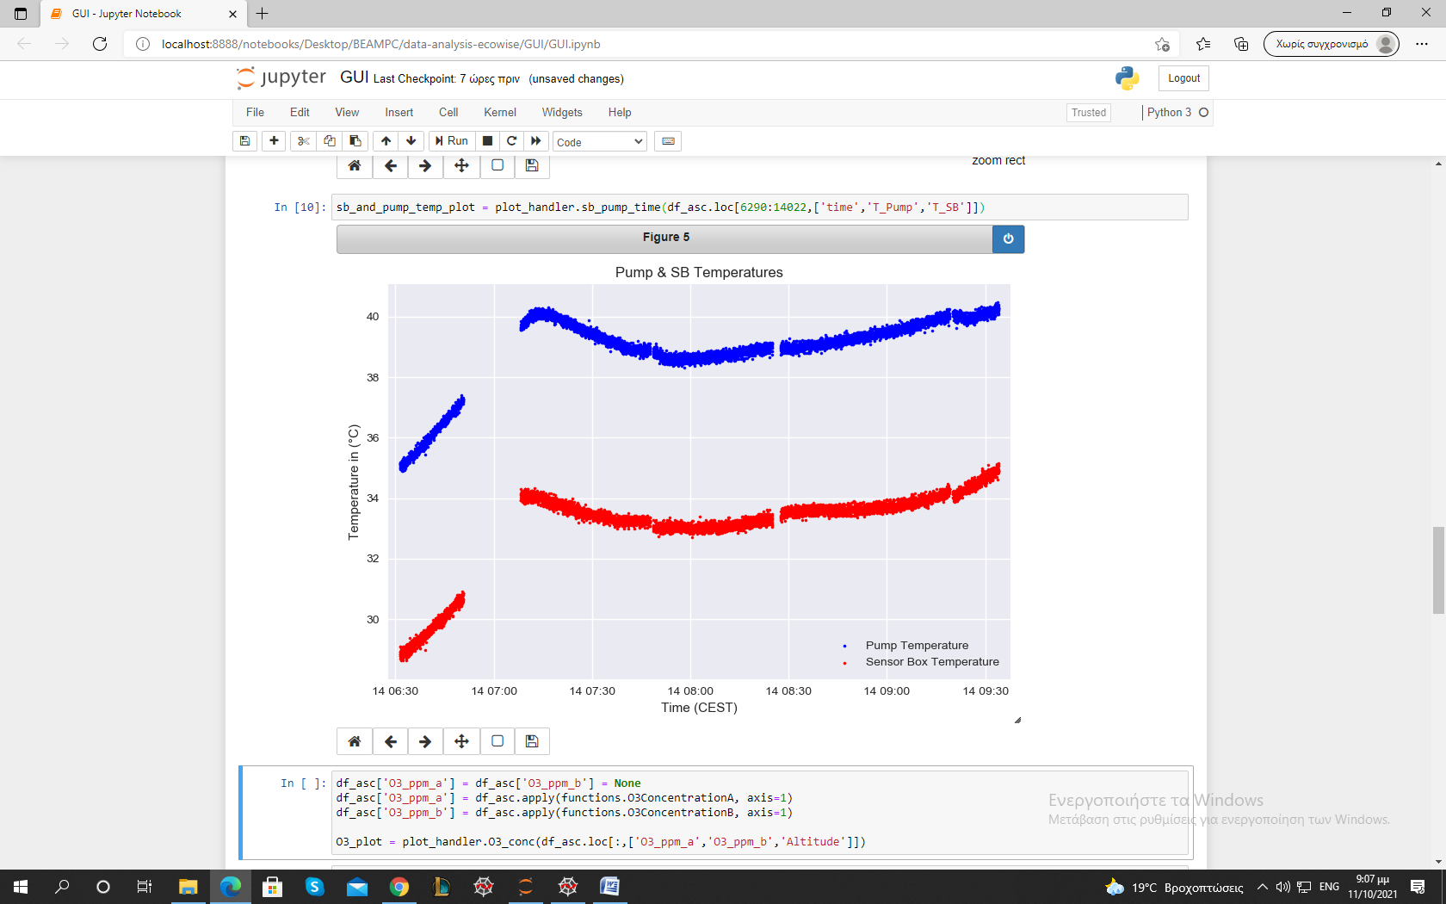

As mentioned above, there exist certain discontinuities in the graphs below which are attributed to a loss of signal as well as the resbooting of the experiment’s systems.

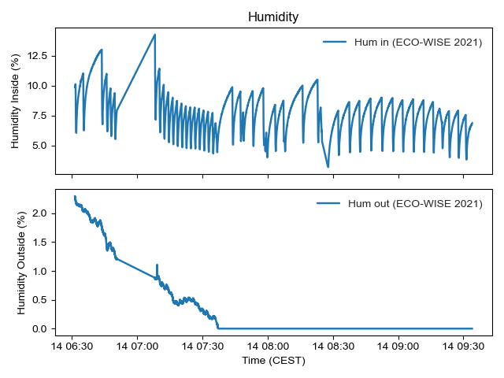

Graph 6: Humidity inside and outside of the sensorbox during the floating phase

The outside humidiity remained relatively stable throughout the floating phase and any changes were mostly gradual with its values ranging from 0 % to 2. 3% . The humidity measured inside however, as can clearly be seen in the graph, varied greatly and changed periodically with every cycle, with its extrema values being [3.17 % , 14.29 %].

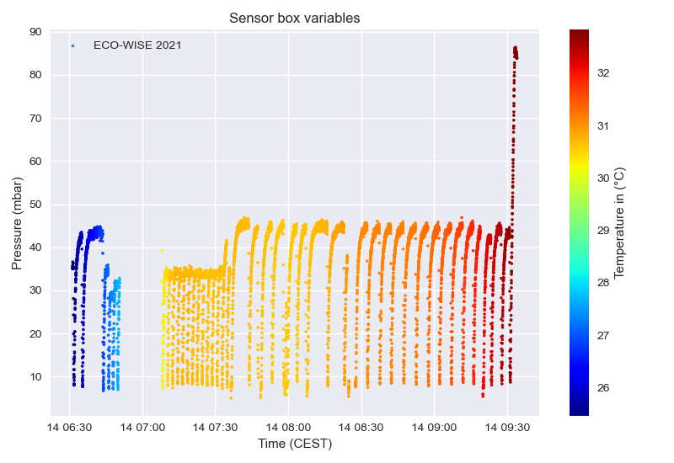

Graph 7: Sensorbox variables during the floating phase

Again, the temperature inside the sensorbox remained relatively stable and slightly higher during the floating phase, in the range [25.5 oC, 32.5 oC]. The inside pressure remained extremely low, and the pump could only raise its value up to 47 mbar with the minimum pressure being 5 mbar.